**CONDUCTOR CONNECTIONS FOR LV & MV ENERGY CABLES FOR WIND TOWER AND WIND PARK APPLICATIONS**

**J. LANGOWSKI, NEXANS POWER ACCESSORIES GERMANY GmbH, Germany**

**SUMMARY**

A stepwise turning away from the utilization of fossil fuels for electrical energy production to a significant increase of renewable energy sources becomes more and more important worldwide. Germany is taking a pioneering role in the deployment of wind energy utilization and has set systematic goals for its extension. Wind energy industry recorded a dramatic growth over the last decade(s) and is still an enormous growing sector of power production in the world. There is a constant need for cost reduction for operating as well as for maintaining wind turbines. Wind towers are usually manufactured in segments, already including all necessary equipment like e.g. LV- cabling but also MV- cabling is being found within turbines. With respect to the different levels of performance, that such energy cables have to provide depending on the tower segment where it is installed, conductor construction mostly vary in size, class, shape or material within the tower segments. During erection of the tower, the energy cable in every single segment needs to be connected to those in the following segment, of course in a secure and reliable way. This paper is about a cost effective, efficient and electrically safe way to assemble the conductor connection inside wind tower segments by mechanical conductor contacts.

**Key words:** energy cable, mechanical contacts, connector, wind tower, wind park, IEC61238, vibration, shock

**INTRODUCTION**

Since 1890 wind turbines are more and more used for generating electrical power. E.g. the Charles F. Brush wind turbine had a rotor 17 m in diameter and was installed on a tower 18 m high (Fig1). The machine was rated at 12 kW.



**Fig 1: One of the first windmills used to generate electrical power. The machine was designed and constructed by Charles F. Brush, 1888-1889 in the USA**

Source: <http://en.wikipedia.org/wiki/File:Wind_turbine_1888_Charles_Brush.jpg>

Until around 1978 technologies for series production of wind turbines where available, initially delivering manageable electrical services of some 10 kW. With the development of e.g. new rotor blade designs, the performance of wind turbines could be increased up to the MW range in the early 1980s. Since then, wind power turbines develop with a rapid speed. The performance of modern series wind turbines today is of ≥ 3 MW, with the first already existing systems working up to 8 MW. Structurally are hub heights of 160 m and a rotor diameter of about 90-95 m for average sized systems achieved, but it’s already a fact that these dimensions will be surpassed by next generation of wind turbines.   
The existing and desired heights and performances of wind turbines yield a high requirement profile for the structural design of wind turbines.

Although essential components of a wind turbine can vary on different models in detail, it’s almost similar in basic structure with the following:   
• foundation and tower. The existing and the for the future desired tower heights leads to production of pre-fabricated elements. While assembled each segment is placed and linked to the other up to the required height of tower. (Fig. 2)  
• nacelle and wind tracking device - azimuth adjustment - (Fig. 3)  
• Rotor and generator with gear or gearless (Fig. 3)  
• inverter  
• transformer . According to the performance requirements of the transformer is placed either in the nacelle, in intermediate regions below, on tower foundation or outside the tower  
• power cable. Depending on the structure of the wind turbine generated power is fed down the tower via low-or medium voltage cables   
• reactive power compensation  
• network connection into different electrical grids (10-30 kV grid at individual facilities, 110 kV grid for larger wind farms)

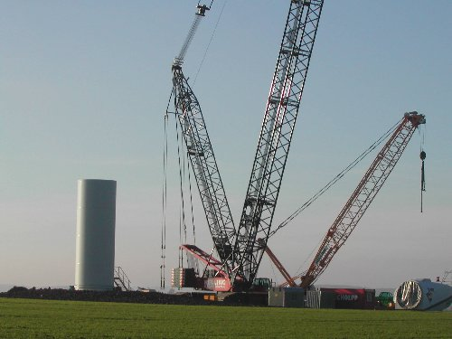

**Fig2: Tower structure placed in pre-fabricated elements**

**Quelle:** [**http://www.hdi-gerling.de**](http://www.hdi-gerling.de)

**(Sicherheitsinformationen)**

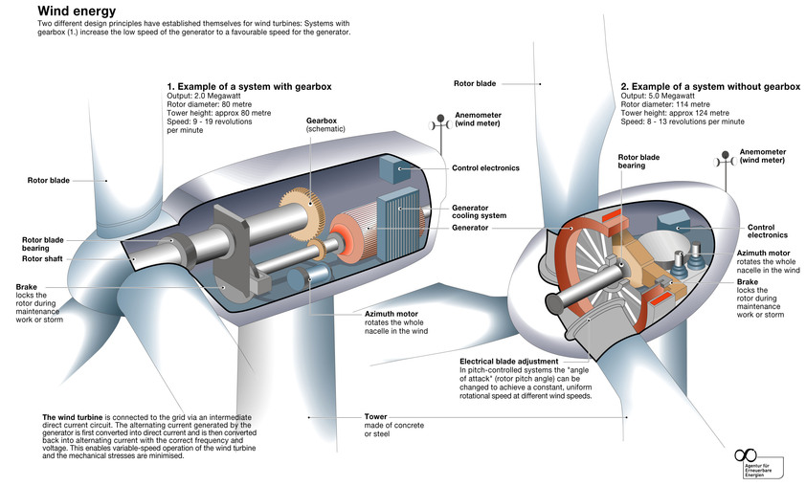

**Fig 3: Wind turbine with gear and gearless**

**Source:** [**http://www.unendlich-viel-energie.de/mediathek/grafiken/wie-funktioniert-eine-windkraftanlage3**](http://www.unendlich-viel-energie.de/mediathek/grafiken/wie-funktioniert-eine-windkraftanlage3)

**PAPER TEXT**

Damage to central parts of the plant such as substation, transformer, reactive power compensation, switchgear, can not only lead into failure of individual wind turbines, sometimes even into service interruption for the complete wind park. A most carefully planning and selection of materials for the production and assembly of wind turbines should minimize the risk of commercial losses due to longer service interruptions. Reliability and low maintenance are key factors governing the profitability of wind turbines, as downtime and repair are prohibitively costly.

In this spirit a particular attention should be focused also on the transportation and connection of the generated power to the internal wind farm energy grid as well as to the power distribution net, and of course with a view to tower internal energy cable installation. Whether the generated power is running through LV or MV cables inside the tower depends on the local placement of the transformer. If the transformer is placed in the nacelle of the wind turbine, the internal tower cable is a medium voltage cable. To connect medium voltage cable use of pre-fabricated jumper cables equipped with e.g. encapsulated separable connectors and / or terminations has been proved to be advantageous. Since both terminations and separable cable connector parts are relatively sophisticated in the accessory installation on medium voltage cables, those jumper cables are usually pre-assembled and pre-tested electrically by the manufacturer prior to leaving the factory. (Fig. 4)

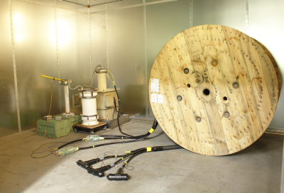

**Fig. 4: Electrical testing on jumper cables for AC and PD at Nexans-Power-Accessories Germany GmbH plant (Elektrische Prüfung einer vorkonfektionierten Mittelspannungsleitung bei der Nexans-Power-Accessories Germany GmbH)**

**Source:** [**www.nexans-power-accessories.com**](http://www.nexans-power-accessories.com)

If the transformer is placed at the base or even outside the towers the internal tower cabling can be done with low-voltage cables. If the structure of the wind turbine tower takes place in pre-fabricated elements the LV power cables are often also pre-installed at every element and must be connected on site to each other with corresponding conductor connections.   
The connection of such tower cables needs to be considered more in detail here.

With regards to the technology of wind turbines the conductor connections for low-or medium-voltage cable in Wind turbines are exposed to:   
  
  
  
o **extension and contraction forces**

Induced by extension and contraction of the power cable conductor and the

rotary movement of the nacelle.  
o **high alternating between strong and low current load**

For economical reasons the cables for the connection of wind turbines are used close to their current limits when the maximum power is produced but during absence of wind the loads are close to zero.

o **subjected to substantial vibrations**   
Vibration is not only the affect of generator operating. Moreover the primary loading on wind turbines is due to wind and seismic forces.

In case of use of pre-fabricated elements and therefore with pre-installed power cables following tasks need to be considered too:   
   
o **change of conductor-materials, -shapes, -classes and cross-sections in one energy line**

For weight and of course cost reasons conductor material changed between Cu an AL. The material change leads into different cross sections need to be connected. Different requirements in power cable laying may necessitate a change in the conductor class e.g. different bending radii.

o **safe and simple installation**A failure-minimizing, rapid assembly of the connectors is mandatory taking in account all energy cable conductors in use. On top of that eventually existing disparities in the alignment of conductor as result of different cable layings needs to be considered as well.

Installation should be possible without special tool- requirements while ergonomic stress on installers has to be minimized.

**CONCLUSION:**

Within the significant growing in electrical service of the wind turbines the right selection of connectors for power cable conductors becomes more and more relevance especially under the aspect of necessary reducing the potential service interruption of wind farms caused by inadequate performance of such conductor systems. There are different products in different technologies (e.g. mechanical or compression technology) available in the market but for all of them it becomes clear that they are not automatically suitable for wind tower application by passing successful the electrical type test according to IEC 61238 "Compression and mechanical connectors for power cables for rated voltage up to 36 kV (Um = 42 kV)." Moreover there is a certain number of additional requirements should be considered in the selection of products, as mentioned above.

Today mechanical connectors with e.g. share-off bolts has been proven as a reliable and money

saving way of connecting different conductor cross sections and conductor materials in wind towers used under the described circumstances. Those products fulfill all installation requirements combined with an easy and safe way of installation and can come along as standard connector as well as in a split bold design.

(Fig.5: Installation of roll-on joint with split- bold contact).

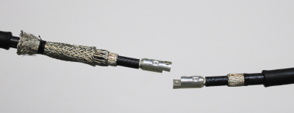 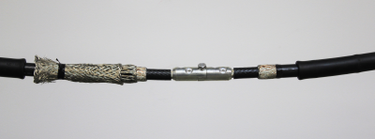

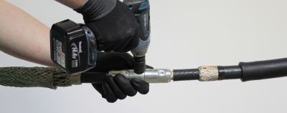 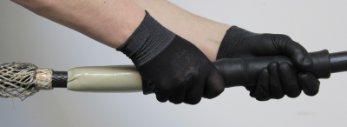

**Fig. 5: Installation of a roll-on joint including split- bold connector**

**Source: Internet** [**http://www.nexans-power-accessories.com/fileadmin/pdfs/deutsch/GPH_Kataloge/Katalog_D-komplett.pdf**](http://www.nexans-power-accessories.com/fileadmin/pdfs/deutsch/GPH_Kataloge/Katalog_D-komplett.pdf)

For wind application it is recommended to decide the use of products that have been proven their suitability in vibration- and shock–test in addition to the as fundamental and mandatory required electrical test according to IEC 61238 to increase the reliability of wind turbines and to minimize operational downtime. (Fig. 6)

J.Langowski, Nexans Power AccessoriesGermany GmbH, Ferdinand-Porsche-Straße 12, 95028 Hof, Germany

Tel.: 0049 201-27894102, E-Mail: Joerg.langowski@nexans.com